Arduino Snake Game Project Report

1. Project Description
This project encompasses the design of a "Snake Game" using an Arduino Uno, utilizing a joystick, LCD screen, buzzer, and potentiometer. The primary objective of the game is for the snake, moving on the screen, to collect "*" symbols to earn points while avoiding "#" symbols to prevent losing the game. This project serves as an application example that integrates both hardware circuit design and software programming knowledge.

2. Objective
The aim of this project is to understand the operation of fundamental electronic components and to enhance Arduino programming skills while designing and implementing a game. Additionally, it targets learning control mechanisms via a joystick, data visualization techniques using an LCD screen, and managing adjustable parameters with a potentiometer.

3. Connection to STEM
Projects that integrate STEM (Science, Technology, Engineering, Mathematics) disciplines aim to help students gain both theoretical and practical knowledge in these fields. This project connects to STEM in the following ways:
- Science: The operating principles of sensors like the joystick and LCD screen, as well as the differences between analog and digital signals, are examined.
- Technology: Programming a microcontroller platform like Arduino and integrating hardware components contribute to the development of technological skills.
- Engineering: During the design phase, logical planning is executed to ensure correct component connections and the systematic operation of the device.
- Mathematics: Mathematical applications such as calculating the snake's movement coordinates and converting joystick analog data into digital positions are included in the project.
This project highlights the unifying power of STEM fields, aiming to develop students' creativity and problem-solving abilities.

4. Materials Used
- Arduino Uno: The microcontroller board acting as the brain of the project.
- Joystick: Allows the player to control the snake.
- 16x2 LCD Screen: Creates the visual interface of the game and displays the snake's movements.
- Buzzer: Emits a warning sound when the game is lost.
- Potentiometer: Used to adjust the contrast of the LCD screen.
- Resistors and Jumper Wires: Ensure the completion of the electrical circuit.
- Breadboard: Used for temporary circuit design.

5. Game Rules
- The snake is moved using the joystick.
- The snake earns 1 point when it reaches the "*" symbol.
- The game is won when a total of 6 points is reached.
- The game ends and restarts if the snake touches the "#" symbol.

6. System Design

6.1 Hardware Connections
- Joystick: X-axis, Y-axis, and button pins are connected to the relevant analog and digital pins of the Arduino.
- LCD Screen: The screen pins are connected to the corresponding Arduino pins.
- Potentiometer: Connected to the LCD screen pins for contrast control.
- Buzzer: Connected to a digital pin on the Arduino.
- Power: A computer is used via USB cable to supply power to the Arduino.

6.2 Software
The game software was developed using the Arduino IDE. In the software, joystick inputs are read as analog values, and the snake's movement is adjusted according to this data. The "LiquidCrystal" library was used for the operation of the LCD screen.
Before moving to the final game code, we proceeded step-by-step to ensure all devices were working correctly.

Step 1: LCD Screen and Potentiometer Connection
Unlike the connections shown in the image below, our LCD connections are as follows: RS -> 7, E -> 6, D4 -> 5, D5 -> 4, D6 -> 3, D7 -> 2 .
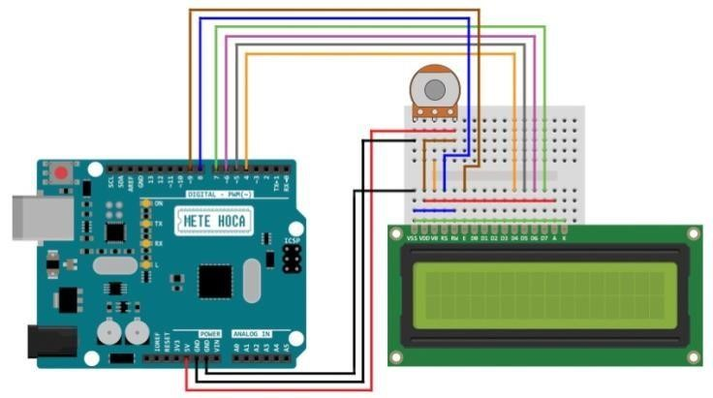
Test Code:
#include <LiquidCrystal.h>
LiquidCrystal lcd(7, 6, 5, 4, 3, 2);

void setup() {
lcd.begin(16, 2);
lcd.print("Hello!"); // "Merhaba!"
}

void loop() {}

Step 2: Adding the Buzzer
The Buzzer's anode leg is connected to digital pin 10, and the cathode to GND.
Test Code:
#include <LiquidCrystal.h>
LiquidCrystal lcd(7, 6, 5, 4, 3, 2);
const int buzzerPin = 10;

void setup() {
lcd.begin(16, 2);
lcd.print("Hello!");
pinMode(buzzerPin, OUTPUT);
}

void loop() {
digitalWrite(buzzerPin, HIGH);
delay(1000);
digitalWrite(buzzerPin, LOW);
delay(1000);
}

Step 3: Adding the Joystick
Joystick connections: GND -> GND, +5V -> 5V, VRX -> A0, VRY -> A1, SW -> 9 .
Test Code:
#include <LiquidCrystal.h>
LiquidCrystal lcd(7, 6, 5, 4, 3, 2);

const int VRX = A0; // Joystick X-axis pin
const int VRY = A1; // Joystick Y-axis pin
const int SW = 9; // Joystick button pin

void setup() {
lcd.begin(16, 2);
// Setting Joystick Pins
pinMode(VRX, INPUT);
pinMode(VRY, INPUT);
pinMode(SW, INPUT_PULLUP);

// Start Message
lcd.print("Joystick Test");
delay(2000);
}

void loop() {
lcd.clear();
// Reading Joystick Values
int xValue = analogRead(VRX);
int yValue = analogRead(VRY);
int swState = digitalRead(SW); // Click state

// Updating LCD Screen based on Joystick values
lcd.setCursor(0, 0);
lcd.print("X:");
lcd.print(xValue);
lcd.print(" Y:");
lcd.print(yValue);

lcd.setCursor(0, 1);
if (swState == LOW) {
lcd.print("CLICKED ");
} else {
lcd.print("NOT CLICKED");
}
delay(200);
}

Main Game Code Features
- Joystick Control: Movement is detected based on values from the X and Y axes.
- Snake Movement: The snake's position updates based on joystick input.
- Scoring: Score increases when the snake touches "*". Reaching 6 points triggers a "You Won" message.
- Game Over: Touching "#" ends the game with a buzzer sound and restarts it.
Key Code Components: The code defines variables for the snake's coordinates (snakeX, snakeY), length (snakeLength), and the positions of food and obstacles .
- spawnFood() and spawnObstacle(): These functions generate random positions for food and obstacles, ensuring they do not overlap with the snake's current body .
- displayLoseMessage() and displayWinMessage(): These handle the end-game states and reset the game upon user input .
(Full source code is available in the repository files).

7. Conclusion
This project provided an experience in both putting theoretical knowledge into practice and developing a creative game. Through the hardware components and software techniques used, it bridged STEM disciplines, enhancing technical skills and creativity.
Through this project, students:
- Learned the usage and working principles of electronic components.
- Improved their Arduino programming skills.
- Gained experience in problem-solving and project management.
- Observed how applied work in STEM fields can be integrated into real life.

8. Future Work and Improvement Suggestions
The project can be improved in many ways:
- Level System: The game can be made harder in progressive levels (e.g., increasing speed).
- LED and Audio Feedback: LED lights or specific sounds can be added when points are collected.
- Mobile or Web Control: Integrating Bluetooth or Wi-Fi modules to control the game via mobile devices.
- Larger Screen: Using a TFT screen for better graphics.
- Multiplayer Mode: Designing a version where two players can compete using two joysticks.

9. Contributions to STEM Education
This project plays a significant role in STEM education because it:
- Increases students' analytical thinking, creativity, and technology usage.
- Teaches how different STEM fields work together.
- Allows students to apply theoretical knowledge to real-world problems.
Since it enables the development of an application requiring both technical knowledge and creativity, it can be evaluated as a successful STEM study example.

